

**INTELLIGYM WEBSITE AND APPLICATION**

Prepared by:

**Mohammad Bilal Al-Salahat**

**Abdelrahman Abdallah Basheer**

**Mohannad Ibrahim Jaber**

**Dana Saleem Abu Zenah**

Supervisor By:

**Dr.Ahmed Sharadqah**

**Presented to the Department of Electrical Engineering**

**Computer and Network Engineering**

**At Al-Balqa'a Applied University**

**January, 2024**

**ABSTRACT**

For years, health professionals have warned that there is a global obesity epidemic. The difficulty in getting to the gym didn’t make the situation any better. Many people encounter challenges when attempting to join a gym membership, especially those who do not stay in one place for a long period, such as travelers, tourists, and people whose jobs require them to travel frequently.

Heavy workloads at certain times, the preference for using E-payment, the pressure of mandatory commitment, and the lack of time that makes it feel like a waste of money, are all barriers that face a notable portion of people when they decide to join a gym.

Although some gyms accept E-payments and daily fees, they are often pricey and difficult to locate, so this doesn't completely fix the issue.

Our approach to solve this problem is a platform that is geared toward those who wish to work out in the gym and lead healthier lives without the previously mentioned hassle, by swapping the membership approach for a pay-per-minute one and the possibility of entering any gym nearby.

**INTELLIGYM WEBSITE AND APPLICATION**

**By:**

**Mohammad Bilal Al-Salahat**

**Abdelrahman Abdallah Basheer**

**Mohannad Ibrahim Jaber**

**Dana Saleem Abu Zenah**

**Approved by:**

**Dr.Ahmed Sharadqah**

**Supervisor:**

**Dr.Ahmed Sharadqah**

**ACKNOWLEDGMENTS**

We would like to express our deep and sincere gratitude to our research supervisor, Dr. Ahmed Sharadqah, for the valuable and constructive suggestions and guidance during the planning and development of this project the willingness to give their time so generously is greatly appreciated. Also, we would like to thank our families and friends for their continued encouragement that made this project possible for allowing us to conduct research, and for providing invaluable guidance throughout this research. Their dynamism, vision, sincerity, and drive inspired us to produce a valuable project. They taught us the methodology for conducting research and presenting the research work as clearly as possible, we are very grateful for what they have given us.

We are also extremely grateful to our parents for their love, prayers, care, and sacrifices to educate us and prepare us for our future.

Finally, our thanks go to all the people who have directly or indirectly supported us in complete the research work.

**DEDICATION**

We dedicate this humble project to all our instructors who have supported us throughout our work, especially our supervisor, and of course to our families. We also dedicate this project to our beloved university, and to all the workers there.

**TABLE OF CONTENTS**

LIST OF FIGURES VII

LIST OF TABLES VIII

CHAPTER ONE: INTRODUCTION 1

**1.1** **Overviews** 1

**1.2** **Background** 2

**1.3** **Problem Statement** 5

CHAPTER TWO: RELATED WORK 6

**2.1** **ClassPass** 6

**2.2** **Yoma** 7

**2.3** **GetMuv** 9

**2.4** **Comparison With our Work:** 10

CHAPTER THREE: REQUIREMENTS 12

**3.1** **Reactjs:** 12

**3.2** **JSX** 12

**3.3** **Node.js** 13

**3.4** **Flutter** 13

**3.5** **Dart** 14

**3.6** **UI/UX Design Tools** 14

**3.7** **Firebase** 14

**3.8** **API Integration** 14

**3.9** **Testing Frameworks** 15

**3.10** **Performance Optimization** 15

CHAPTER FOUR: EXPECTRD WORK 16

**4.1** **Proposed Work** 16

4.1.1 Proposed work for Application: 16

4.1.2 Proposed work for website: 19

**4.2** **Deliverables** 21

**4.3** **Functional Requirements:** 22

4.3.1 Functional Requirements for IntelliGym application: 22

4.3.2 Functional Requirements for IntelliGym Website: 24

**4.4** **Non-Functional Requirements:** 25

CHAPTER FIVE: IMPLEMENTATIONS AND RESULTS 26

**5.1** **Software Implementation** 26

5.1.1 Overall Software Design for the App 26

5.1.2 The Selection of Flutter and Dart 26

5.1.3 The Selection of Firebase 27

5.1.4 The Selection of GitHub for Version Control and Teamwork 27

5.1.5 The Usage of React.js for the Website 28

5.1.6 Overall Software Design for the Website 28

**5.2** **Application Screens** 30

5.2.1 Log In Screen: 30

5.2.2 Sign Up Screen 32

5.2.3 Forget Password Screen 34

5.2.4 Dashboard screen 36

5.2.5 Gym Screen 38

5.2.6 Coach Screen 40

5.2.7 Profile screen 42

5.2.8 App setting screen 44

5.2.9 Edit profile screen. 46

5.2.10 Change Password Screen. 48

5.2.11 Session history screen 50

5.2.12 Payment screen 52

5.2.13 QR Code screen 54

5.2.14 Timer screen 56

**5.3** **Website Screen** 58

5.3.1 Home Screen 58

5.3.2 Sign in & signup Screen. 60

5.3.3 Forgot Password Screen 62

5.3.4 Main User Screen 63

5.3.5 Trainees Screen 65

5.3.6 Setting Screen 66

5.3.7 Change Password Screen 68

5.3.8 Upgrade Plan Screen 69

CONCLUSION 70

REFERENCES 71

# LIST OF FIGURES

Figure 1:ClassPass Website and Application 6

Figure 2:Yoma application 7

Figure 3:GetMuv Application 9

Figure 4: Reactjs advantages 12

Figure 5: JSX 12

Figure 6: Node.js features 13

Figure 7: flutter platform 13

Figure 8: Firebase features 14

Figure 9 :Login Screen 31

Figure 10: Sign Up Screen 33

Figure 11: Forgot Password Screen 35

Figure 12: dashboard Screen 37

Figure 13: Gym Screen 39

Figure 14: Coach Screen 41

Figure 15: Profile screen 43

Figure 16: App setting screen 45

Figure 17: Edit profile screen 47

Figure 18: Change Password Screen. 49

Figure 19: Session History screen 51

Figure 20: Payment screen 53

Figure 21: QR code screen 55

Figure 22: Timer screen 57

Figure 23:Home Screen 59

Figure 24:Sign in Screen 60

Figure 25: Join us screens 61

Figure 26:Forgot Password Screen 62

Figure 27: Main User Screen 64

Figure 31:Trainees Screen 65

Figure 28:Setting Screen 67

Figure 30:Change Password Screen 68

Figure 29:Upgrade Screen 69

# LIST OF TABLES

Table 1: Features of IntelliGym with other 11

# CHAPTER ONE: INTRODUCTION

## **Overviews**

Our platform, IntelliGym, is designed to make the gym-going experience more efficient and convenient for trainees, while also providing a powerful management tool for gym staff, coaches, and nutritionists. There are two main components to the platform:

**mobile application:** Say goodbye to time-consuming check-ins and enjoy seamless gym sessions. A session timer that can be started and ended with a simple QR code scan is the main function of the program, simplifying the process of checking in and out. Track your progress and stay motivated with the app's history feature, which logs all sessions.

**website:** This platform feature focuses on management and is intended for gym employees, coaches, and nutritionists., Gym owners, coaches, and nutritionists rejoice! This website is your ultimate hub for efficient management and thriving business. Easily register your gym showcase your expertise and create attention-grabbing posts and announcements. Promote your offerings and attract clients with targeted ads, all things considered, the IntelliGym platform offers a variety of features to enhance the effectiveness and convenience of going to the gym, making it a complete solution for both gym employees and new members.

## **Background**

The proliferation of technology in modern society has led to numerous benefits and advancements, however, it has also been associated with various negative consequences. The overuse of technology has been linked to physical and psychological health issues.

On the physical side, a study published in the journal "Applied Ergonomics" observed a correlation between prolonged mobile phone usage and neck or upper back pain in young adults. Furthermore, a study conducted on young adults aged 19-32 years found that individuals who frequently used social media were more than three times as likely to feel socially isolated than those who did not use social media as often.

On the psychological side, research has shown mixed results on the relationship between social media usage and mental health. A systematic review published in 2016 found that people who had more positive interactions and social support on social media platforms had lower levels of depression and anxiety. On the other hand, some research indicates that an elevated risk of anxiety and depression is linked to excessive usage of social media. Additionally, using technology too close to bedtime can also disrupt the body's natural circadian rhythm, leading to sleep disturbances.

The overuse of technology also has a sedentary lifestyle effect on people, making them lazy and less active. This can lead to an increase in health problems like obesity and heart disease.

It's important to note that not all the effects of technology overuse are negative, and that the key is to find a balance in technology usage. One way to counteract the negative effects of technology overuse is through regular physical activity and exercise. These activities not only improve physical health but also have a positive impact on mental well-being.

According to guidelines established by the World Health Organization, adults aged 18-64 years should engage in a minimum of 150-300 minutes of aerobic exercise at a moderate intensity, or 75–150 minutes of aerobic exercise at a high intensity, or an equivalent mix of moderate and high intensity activity spread out over the course of the week. Additionally, because they offer extra health benefits, muscle-strengthening exercises that involve all major muscle groups at a moderate to high intensity should be done two or more days a week. To further enhance general health, it is advised to reduce the amount of time spent inactive and substitute it with any level of physical activity, even little exercise. All individuals, especially older ones, should strive to engage in more moderate-to-intense physical activity than the prescribed amounts in order to lessen the negative consequences of excessive sedentary behavior on health. Regular physical activity is a crucial component of a healthy lifestyle and has been shown to have a wide range of beneficial effects on both physical and mental health. It plays an important role in preventing and managing non-communicable diseases such as cardiovascular diseases, cancer, and diabetes. In addition, regular physical activity has been shown to reduce symptoms of depression and anxiety. Furthermore, physical activity has been shown to enhance cognitive function, including thinking, learning, and judgment skills.

Despite the numerous benefits of physical activity, a significant proportion of the global population does not meet the recommended levels of physical activity. According to the World Health Organization, approximately 25% of adults worldwide do not engage in sufficient levels of physical activity. This lack of physical activity has been associated with an increased risk of death, with individuals who are insufficiently active having a 20-30% increased risk of death compared to those who are sufficiently active. The situation is even more alarming among adolescents, with more than 80% of the world's adolescent population being insufficiently physically active.

In conclusion, regular physical activity is a vital aspect of maintaining overall health and well-being. It can play a critical role in preventing and managing chronic diseases, reducing symptoms of depression and anxiety, and enhancing cognitive function. Despite the numerous benefits of physical activity, a significant proportion of the global population does not meet the recommended levels of physical activity, highlighting the need for increased awareness and efforts to promote physical activity across all age groups.

Our platform seeks to improve convenience of the gym admissions process, which in turn will help more people meet their recommended training times weekly. Numerous features are available on the platform, including bill payment systems and session timers, and prompts to assist users in staying on course and getting the most out of their gym visit. It also has a map function that displays neighboring gyms, making it simple for users to locate new facilities and meet their suggested training schedules By making it easier for people to visit the gym and offering resources to keep them on track, our platform is designed to help people achieve their recommended levels of physical activity and improve their overall health and well-being.

The traditional gym system can present a number of challenges for individuals who engage in regular travel or experience instability in their lives. One of the major issues is the requirement to register for a minimum period of one month, which can be inflexible for those who frequently travel or move to different locations. Furthermore, individuals who have chronic health conditions that prevent them from being able to attend the gym on consecutive days may also face difficulties in maintaining their gym membership.

To address these challenges, our system employs a new payment system, "pay per minute," which allows individuals to pay for their gym usage on a minute-by-minute basis. This eliminates the need for traditional, long-term registration and allows for greater flexibility in gym usage. Our system also utilizes a QR code scanning system for registration, where the trainee scans the QR code at the gym to start the timer and scans it again when their session is finished.

A healthy diet is essential for the overall well-being of an individual and plays a critical role in preventing malnutrition and a variety of non-communicable diseases (NCDs). However, with A change in dietary patterns has resulted from the increased production of processed foods, fast urbanization, and changing lifestyles. This has led to an increase in the consumption of foods high in fats, energy, free sugars, and salt/sodium, and a decrease in the intake of fruits, vegetables, and other dietary fibers like whole grains.

We also understand the importance of a balanced diet in achieving overall health and fitness goals. That is why our app offers consulting services from certified dietitians. These dietitians are experts in the field of food and nutrition and can provide personalized guidance and recommendations based on an individual's specific needs and goals.

Our goal is to provide a supportive environment for individuals looking to lead healthier lives. By offering a gym membership that is tailored to meet the needs and preferences of each individual, we hope to attract new members and keep them engaged in their physical fitness journeys. This, in turn, will allow us to generate more revenue and establish ourselves as the top gym in the area.

Electronic payment, or e-payment, is the term used to describe the process of conducting financial transactions via electronic devices, such as credit cards, debit cards, or mobile payment apps. E-payment is becoming increasingly popular as it offers several advantages over traditional payment methods. One of the most significant benefits of e-payment is its convenience. E-payment eliminates the need for physical cash or checks, which can be lost or stolen. Additionally, it allows users to make payments from anywhere and at any time.

## **Problem Statement**

The problem that IntelliGym app aims to solve is the lack of accessible and convenient fitness and wellness resources for individuals. Many people struggle to maintain a consistent exercise routine or have limited access to quality gym facilities and nutrition advice. The current options for finding a gym or a personal trainer can be time-consuming, confusing, and overwhelming. Additionally, many people are looking for a more personalized and efficient way to track their fitness progress and receive advice from experts in the field. IntelliGym app aims to address these pain points by providing a comprehensive platform that combines gym facilities and fitness classes with personal training and nutrition services, all in one place and accessible through a mobile app.

# CHAPTER TWO: RELATED WORK

In the development of the gym website and application, it is important to review and consider previous projects and applications that have focused on similar goals. This section provides an overview of some notable related works in the field of gym websites and applications:



## **ClassPass**

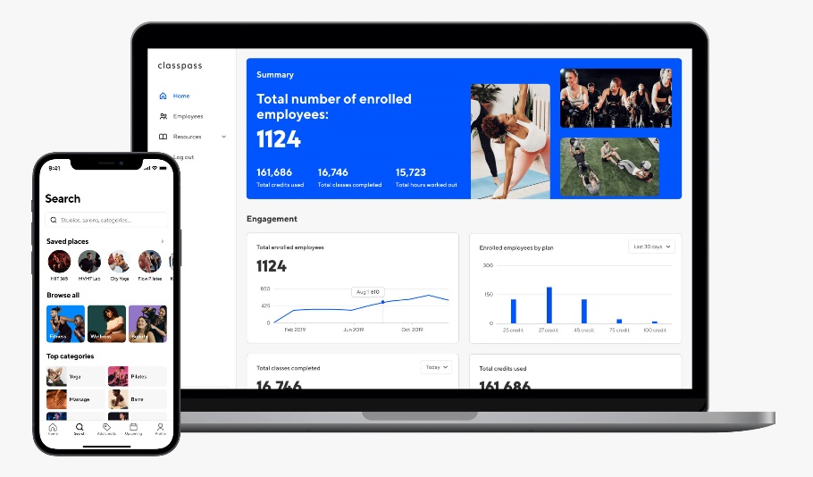ClassPass is revolutionizing the fitness and wellness industry by bringing together the world’s best experiences into one app. their mission to motivate people to live inspired lives every day by introducing and seamlessly connecting them to soul-nurturing experiences. [1]

Figure 1:ClassPass Website and Application



**Features offered of ClassPass:**

* **Affordability:** ClassPass is a more affordable way to try out different fitness classes and studios. You can save money compared to paying for individual classes or memberships.
* **Convenience:** ClassPass is easy to use. You can book classes directly through the app or website, and you can see your upcoming classes and credits in one place.
* **Community:** ClassPass has a vibrant community of fitness enthusiasts. You can connect with other users, get workout advice, and find motivation.
* **Variety:** ClassPass offers a wide variety of fitness classes, including yoga, Pilates, barre, spin, boxing, and more. You can also find classes that focus on specific goals, such as weight loss, strength training, or flexibility.

**Here are some of the cons of ClassPass:**

* **Limited availability:** ClassPass classes can sell out quickly, especially popular ones. You may not always be able to get the class you want, especially if you are on a tight schedule.
* **Hidden fees:** ClassPass charges a monthly membership fee, as well as a booking fee for each class. These fees can add up, especially if you are not using ClassPass very often.
* **No commitment:** ClassPass is a month-to-month membership, so you can cancel at any time. However, if you cancel mid-month, you will lose any unused credits.

## **Yoma**

It provides you with the opportunity to practice various sports and exercises through a large network of sports clubs and a group of distinguished trainers. You can search for dozens of exercises and book in advance through our application simply. [2]

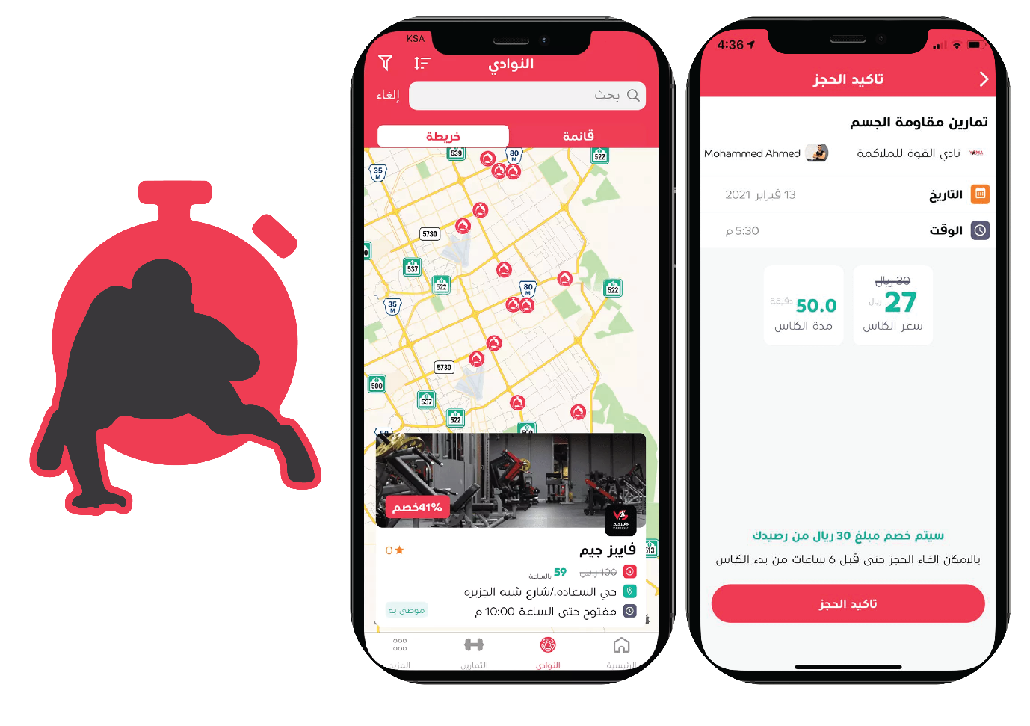

Figure 2:Yoma application

**Features offered of Yoma:**

* **Book gym classes by the minute**: You can book gym classes by the minute, so you only pay for the time you use. This is a great way to save money and only work out when you have time.
* **No long-term contracts or commitments:** There are no long-term contracts or commitments with Yoma, so you can cancel your subscription at any time. This is a great way to try it out without having to worry about being locked in.
* **Easy to use app:** The Yoma app is easy to use and navigate. You can easily find classes, book classes, and track your progress.
* **Safe and secure payments:** Yoma uses safe and secure payments, so you can be confident that your information is protected.
* **To search for gyms**: Users can search for gyms in their area through the Yuma Sports application. The application will provide a list of nearby gyms.

**Here are some of the cons of Yoma:**

* **Limited availability:** Yoma is only available in Saudi Arabia.
* **Limited class selection:** The class selection on Yoma is not as extensive as some other fitness apps.
* **Peak time surcharges:** Yoma charges a surcharge for classes during peak times, such as weekdays during the workday.
* **No cancellation policy:** There is no cancellation policy with Yoma, so you will be charged for any classes that you book, even if you don't show up.
* **Technical difficulties:** There have been some reports of technical difficulties with the Yoma app.

The application does not contain nutrition experts, nor does it contain evaluation of coaches and gymnasiums, and it does not support the feature. The application does not contain nutrition experts, nor does it contain evaluation of coaches and gymnasiums, and it does not support the feature of direct communication with coaches and nutrition experts. of direct communication with coaches and nutrition experts

## **GetMuv**

GetMuv is a good app for users who are looking for an easy way to book gym classes at different gyms in Saudi Arabia. The app provides a range of features that make it easy for users to find suitable gym classes, book them, and track their training progress. [3]

 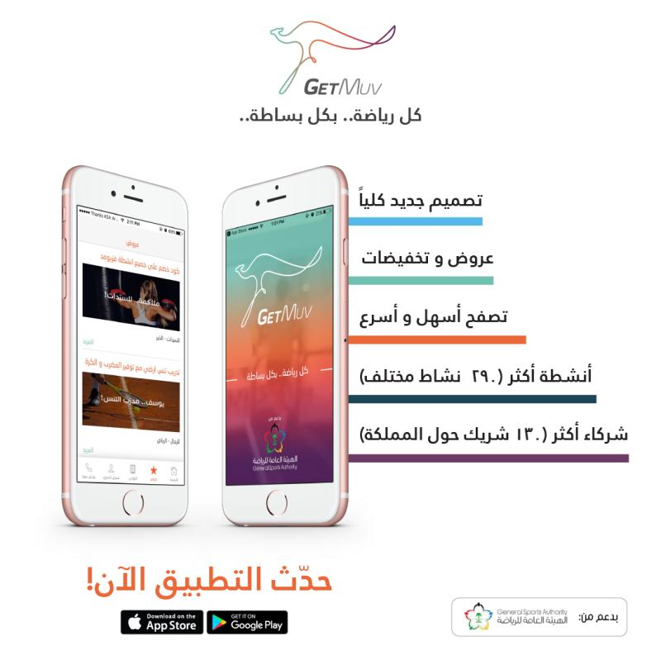

Figure 3:GetMuv Application

**Features offered of GetMuv:**

* **To search for sports and sports centers:** Users can search for different types of sports and sports centers in their area through the GetMuv application. The app will provide a list of nearby sports and fitness centres, including contact information, address and opening hours.
* **Booking sports classes**: Users can book sports classes in different sports centers through the GetMuv application. The application will provide a list of available trainers, as well as information about their experience and specializations.
* **Track Training Progress:** Users can track their training progress through the GetMuv app. The application will provide a record of the exercises performed, as well as comments and tips from the trainers.

**Here are some of the cons of GetMuv:**

* **Price:** The prices of some sports classes in the application may be relatively high. For example, a yoga class might cost 100 SAR.
* **Inaccurate Reviews:** Some reviews and comments posted on the app may be inaccurate or subjective. For example, users may leave negative ratings or comments about a particular gym or trainer based on a single bad experience.
* **Customer support is not always available**: Customer support in the app may not always be available, especially during peak times. Users may have difficulty contacting the customer support team if they face any issues with the app.

## **Comparison With our Work:**

**IntelliGym**

* Aims to revolutionize the fitness industry by providing a comprehensive and convenient platform enabling users to keep track of their fitness objectives, communicate with elite trainers and nutritionists, and monitor their progress.
* Offers innovative features such as QR code scanning, real-time session tracking, and a directory of nearby gyms.
* Focuses on security and ease of use.
* Provides a unique and valuable solution for the modern fitness enthusiast.

**Other fitness apps**

* Typically offer a limited set of features, such as tracking workouts and providing workout plans.
* May not be as secure or easy to use as IntelliGym.
* May not offer the same level of personalization or community support as IntelliGym.

**Here are some specific ways in which IntelliGym stands out from other fitness apps:**

* **QR code scanning:** IntelliGym users can scan QR codes at gyms to automatically check in and start tracking their workout. This is a more convenient and efficient way to track workouts than manually entering the gym name and location.
* **Real-time session tracking:** IntelliGym users can track their workouts in real time, including the number of calories burned, distance traveled, and heart rate. This data can be used to track progress and make adjustments to workouts as needed.
* **Directory of nearby gyms:**IntelliGym users can easily find nearby gyms that offer the classes and amenities they are looking for. This is a great way to find a gym that is convenient and fits their needs.
* **Personalization:** IntelliGym uses data from user workouts to create personalized workout plans and recommendations. This helps users stay on track and achieve their fitness goals.
* Community support: IntelliGym users can connect with other users and coaches to get support and motivation. This can be a valuable resource for people who are new to fitness or who are trying to reach a specific goal.

Table 1: Features of IntelliGym with other

|  |  |  |
| --- | --- | --- |
| **Feature** | **IntelliGym** | **Other** |
| **Affordability** | Book gym classes by the minute, so you only pay for the time you use. | Varies depending on the features and services used. |
| **Convenience** | Easy to use app with a variety of features. | Easy to use and navigate. |
| **Community** | Users can connect with Nutrition experts and coaches to get support and motivation. | No community features. |
| **Personalization** | Uses data from user workouts to create personalized workout plans and recommendations. | No personalization features. |
| **Security** | Uses state-of-the-art security measures to protect user data. | Safe and secure payments. |
| **Availability** | Available in All country | Only available in Specific countries |

# CHAPTER THREE: REQUIREMENTS

**The application in this project was developed using a variety of tools and technology, which this chapter will highlight**.



## **Reactjs:**

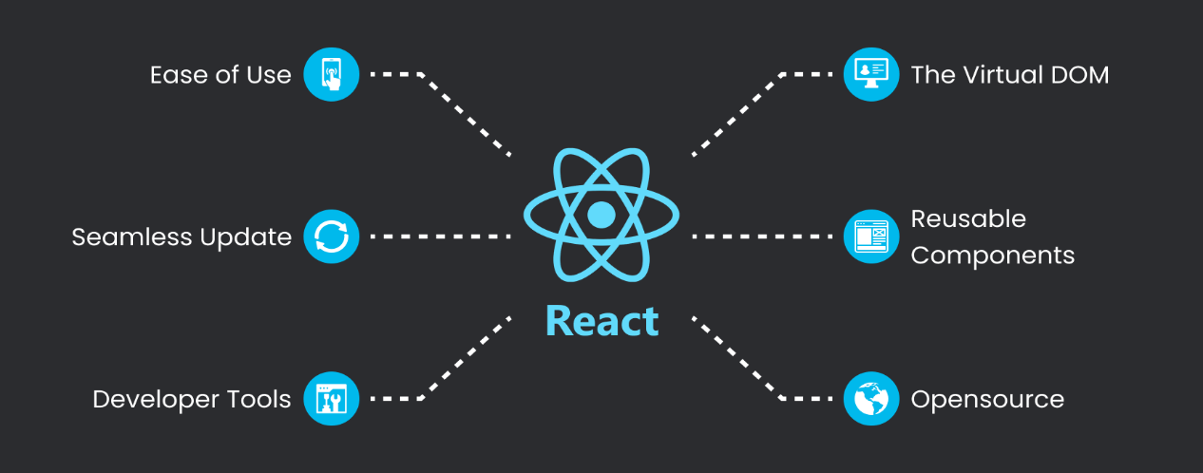ReactJS (often referred to as React) is an open-source JavaScript library for building user interfaces, particularly for single-page applications and reusable UI components. It was developed and is maintained by Facebook, and it has gained significant popularity within the web development community. [4]

Figure 4: Reactjs advantages

## **JSX**

JSX (JavaScript XML) is a syntax extension that allows you to write HTML-like code within your JavaScript. It makes it easier to define the structure and content of your components. [5]

Figure 5: JSX

## **Node.js**

Node.js is an open-source, cross-platform runtime environment that allows developers to execute JavaScript code on the server side. Traditionally, JavaScript was mainly used for front-end web development, running in browsers. However, Node.js extends the use of JavaScript to the server side, enabling developers to build scalable and high-performance applications. [6]

Figure 6: Node.js features

## **Flutter**

Flutter is a cross-platform framework developed by Google that allows you to build native interfaces for iOS and Android using a single codebase. It provides a rich set of pre-built UI components and libraries for building beautiful and responsive user interfaces. [7]

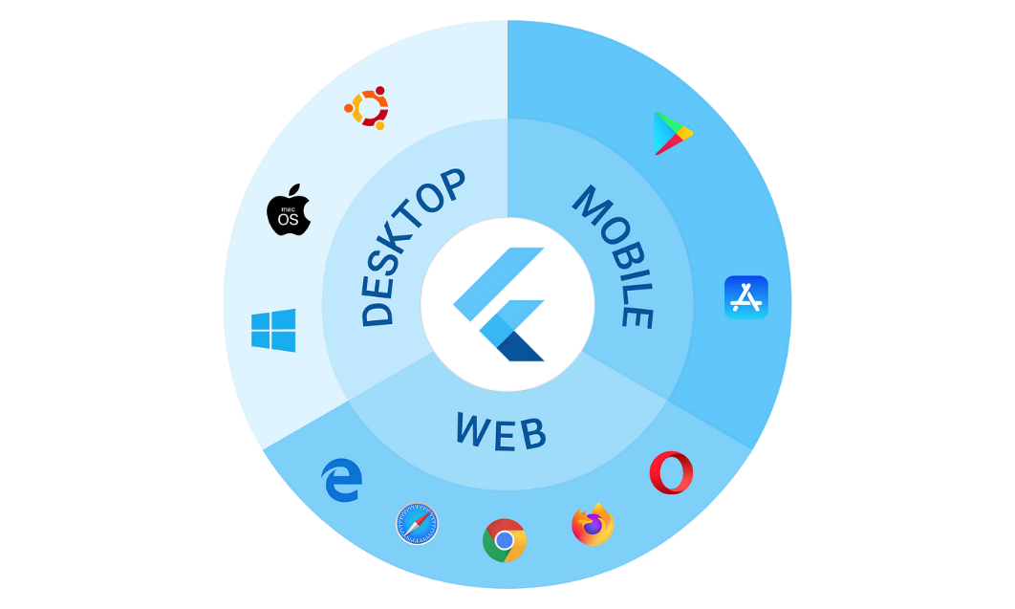

Figure 7: flutter platform

## **Dart**

Dart is the programming language used in Flutter development. It is an object-oriented, class-based language with C-style syntax. Dart is used to write the logic and functionality of the frontend application. [8]

## **UI/UX Design Tools**

To design the user interface of the frontend application, designers often use graphic design tools such as Adobe XD, Sketch, or Figma. Figma has been used as one of these tools, enabling designers to produce wireframes, prototypes, and graphic designs that can be distributed to the development team.

## **Firebase**

Firebase is a Backend-as-a-Service (BaaS) platform developed by Google. It provides a set of tools and services that facilitate backend development, including authentication, real-time database, cloud storage, and cloud functions. Firebase can be integrated with Flutter to handle user authentication, data storage, and serverless functions. [9]

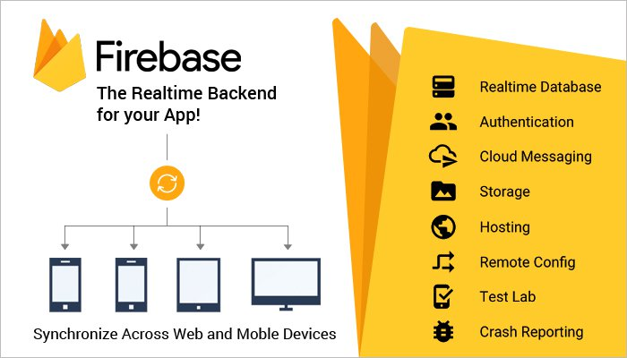

Figure 8: Firebase features

## **API Integration**

Many fronted applications require integration with external APIs to fetch data or interact with external services. For example. Flutter provides libraries and packages for making HTTP requests and handling API integrations. [10]

## **Testing Frameworks**

Software testing is a crucial component of software development that guarantees the application's functioning and quality. To write unit tests and integration tests and automate the testing process, Flutter offers testing frameworks like Flutter Testing and Integration Testing.

## **Performance Optimization**

Optimizing the performance of the front-end application is crucial to provide a smooth and responsive user experience. Techniques like code optimization, image compression, lazy loading, and caching can be employed to improve the application's performance.

**Used Technologies**

The IntelliGym platform leverages the latest in web and mobile technologies to deliver a seamless user experience. The website is built using Node.js for server-side operations, React.js for the front-end, and Bootstrap for styling and responsive design.

The platform's real-time database, provided by Firebase, makes sure that the data is constantly current and available from any location. Flutter, Dart, and Firebase are used in the development of the mobile app to create a native, quick, and intuitive user experience. Both the website and app have been designed to work in harmony with the real-time database, ensuring that the data is always in sync and providing users with a consistent experience regardless of the device they are using.

**UI/UX:**

The IntelliGym mobile application has put a lot of thought into the UI and UX design to ensure the best user experience. By following the six common UI design principles such as structure, simplicity, visibility, feedback, tolerance, and reuse, the app is able to provide an organized, clear, and user-friendly interface. All these design elements work together to create a professional and beautiful experience for the user.

# CHAPTER FOUR: EXPECTRD WORK



## **Proposed Work**

### Proposed work for Application:

**Login**

The IntelliGym mobile application serves as the primary portal for clients to access the app and its offerings. This page has been designed with comprehensive authentication and security measures to ensure the confidentiality and protection of client data.

The interface typically includes two fields: a username field and a password field. After entering their password and username in the appropriate spaces, users click a button to log in.

When a user enters their username and password into the login interface and clicks the login button, the application sends the username and password to the application server for authentication. If the username and password are valid, the application server grants the user access to the application.

**Sign up.**

The application signs up interface that contains a username field, an email address field, a password field, and password configuration options:

* **Username:** The username is a unique identifier for the user. It is typically a string of characters, but it may also be an email address or another type of identifier. The username should be easy to remember and type, but it should also be unique enough to prevent other users from choosing the same username.
* **Email address:** The email address is used to verify the user's identity and to send them important account information, such as password reset instructions. The email address should be a valid email address that the user has access to.
* **Password:** The password is a secret string that the user uses to authenticate themselves to the application. The password should be at least 8 characters long and should include a mix of uppercase and lowercase letters, numbers, and symbols. The password should be difficult to guess, but it should also be easy for the user to remember.
* **Password configuration:** Retype the password again to confirm it
* **Create account:** When a user signs up for an application, they will typically be required to enter all of the information in the sign-up interface. The application will then verify the user's information and create an account for them. The user will then be able to log in to the application using their username and password.

**Forget password.**

The forget password interface is a user interface that allows users to reset their passwords when they have forgotten them. The interface typically consists of a field for the user to enter their email address, and a button to send a password reset link to the user's email address.

When the user clicks the "send link to your email" button, the application sends a password reset link to the user's email address. The password reset link contains a unique code that the user can use to reset their password.

The user clicks the password reset link in their email to change their password. They can input their new password on the password reset page that appears after clicking the link. After that, the user will be able to use their new password to get into the application.

**Dashboard**

The dashboard interface is the main screen of the application that users see after they log in. It typically contains your profile at the top of screen and a search bar that users can use to search for nearby gyms.

The dashboard may also include categories of popular coaches.

When you find a nearby gym, its name, rating, and location will appear to you, and you can know its status open or closed, working hours, days, and communication with the gym.

And we can see the profile of the coaches, his working hours in the gym, his rating, and his private accounts to communicate with him.

**Notifications**The Notifications page, accessible from the bottom navigation bar, displays read and unread notifications in a clear and intuitive manner. Users can quickly identify the status of their notifications, ensuring that they stay informed and up to date on important updates from the IntelliGym app. The page provides an organized and user-friendly way to manage notifications, helping users to stay in the loop without feeling overwhelmed by excess information.

**Profile**

The profile page of the IntelliGym mobile application is designed to offer users easy access to their personal information and settings within the app. The page features the user's name and email, providing a comprehensive overview of the user's profile. The page includes a range of buttons and links that allow users to modify their profile settings.

**Coaches screens**

The Coaches screens within the IntelliGym app provide detailed information about individual coaches. These screens display their status, ratings, and availability in terms of scheduling. Users can also easily contact these professionals, as well as view and write reviews about their experiences. This allows users to make informed decisions about which coaches are best suited to meet their needs.

**Scan QR code**

The QR Scanner is a feature in the IntelliGym mobile application that allows users to easily track and record their gym sessions. This is a button that the user clicks to scan the QR code. When the user clicks the scan button, the camera preview will be activated, and the user will be able to scan a QR code. The QR Scanner then calculates the coins consumed based on the time elapsed during the session.

**Payment**

The payment page within the IntelliGym mobile application offers a user-friendly and secure experience for making subscription payments. The subscription page presents options to pay via credit card, PayPal, or Apple Pay. Upon successful payment, a confirmation page is displayed, ensuring users that their payment has been processed. This page is designed to streamline the payment process, making it easy and convenient for users to make their subscription payments.

### Proposed work for website:

**Home**

The IntelliGym system consists of several distinct sections, each serving a specific purpose. The Home page is designed to engage and entice potential users, showcasing the unique aspects of our system. The Services section provides a comprehensive overview of all offerings and features, allowing users to understand the full scope of what IntelliGym has to offer. The Partners section highlights our key partnerships with gyms, companies, and coaches, reinforcing the quality and reliability of our system. The About section provides detailed information about our company and mission, answering any questions or concerns a potential user may have. The Contact Us section offers a convenient form for users to communicate directly with our team, and the Sign in and Join Us sections provide quick and easy access to the system.

**Sign In**

Access to the account is granted through the use of an email address and password, specifically for Gym, Coach, or Nutritionist identification and authentication.

**Join Us Screen**

* Join as a (GYM) organization that connects you to the organization sign up page.
* Join as a coach or nutritionist that connects you to the coach & nutritionist sign up page.

**Registration Form:**

The Registration Form comprises of the following fields, which are applicable to all users seeking to join the system:

* Email
* Password
* Confirm Password
* Name or Organization Name (distinct field for individual and organization registration)
* Phone
* Acceptance of terms and conditions.

**Main User Screen:**

The Main User Screen comprises several elements to provide a comprehensive user experience. The User Info Side features the user's photo, personal information, and access to the settings and logout options. The Navigation Bar includes the Overview and Trainees sections, providing a clear and intuitive navigation system. The Overview section displays the user's status through various statistics, such as trainee activity and performance.

**Trainee Information Screen:**

The displays a comprehensive list of registered trainees. It features the following components:

Trainee Name: A comprehensive list of trainee profiles.

Trainee Count: The total number of registered trainees.

Add Note Feature: A function that allows coaches or gyms to add notes for each trainee.

**Settings**

**The setting component includes the following sub-sections:**

**Information:** This section allows the user to manage their profile picture, name, password, phone, and additional information

**Upgrade:** the provides the option to upgrade the current subscription plan, The screen also displays the current plan and its expiration date.

## **Deliverables**

The IntelliGym project will deliver two applications, a mobile app for trainees and a website for gyms, coaches, and nutritionists. The mobile application provides several functions and services, including a sign-up process that grants the user free coins for use in participating gyms. The app also features a QR code scanning system for tracking training sessions, a dashboard with statistics, session history, nearby gym locators, announcements from coaches, nutritionists, and gyms, billing options, and user profiles for trainees, and coaches. A leaderboard is another feature of the program that encourages competition. The website, designed for gyms, coaches, and nutritionists, features a main page that provides information about the services offered by IntelliGym Users can sign in if they are already members, join as a gym, coach, or dietician, or both. The main screen of the website offers an overview of trainee statistics. Users can edit their profiles and update their subscription plans. The website will provide a centralized platform for gyms, nutritionists, and coaches to manage their services and trainees in an organized and efficient manner.

## **Functional Requirements:**

### Functional Requirements for IntelliGym application:

* **User Account Management:**

sign up: A process for creating a new user account within the app.

Login: A secure login process for existing users to access their account.

* **Navigation Bar:**

This interface allows users to navigate between different screens in the IntelliGym application.

* **Nearby Gyms:**

Nearby Gyms: A map view of nearby gyms and fitness facilities, allowing users to find and explore new locations.

* **QR Scanner:**

A feature for scanning QR codes at participating gyms for tracking user attendance.

* **Timer:**

A timer to keep track of workout sessions and time spent at the gym.

* **Location services:**

This option allows users to turn on or off location services for the application. Location services can be used to provide users with more accurate information about nearby gyms and activities.

* **Change password:**

This option allows users to change their password for the application. This can be helpful if users think their password has been compromised or if they simply want to change it for security reasons.

* **Session History:**

A record of past workout sessions, including date, time, and duration.

* **Gyms and Coaches Feed:**

Announcements: A feed of announcements from participating gyms and fitness coaches.

* **Payment:**

In this interface, information is entered on the approved method for paying the session cost and confirming the payment process.

* **Payment status:**

calculate the cost of using the gym will appear in the payment field, and the payment process will be done by visa.

* **About:**

An informational page about the app and its developers.

### Functional Requirements for IntelliGym Website:

* **User authentication:**

Email & password login for existing users.

Email, password, name/organization name, phone, and terms acceptance for new user registration.

* **Home Screen:**

Display the main idea of the system.

Display sections for services, partners, about, contact us, sign in, and join us.

* **Sign In Screen:**

Email & password login for existing users.

* **Join Us Screen:**

Option to join a gym organization or as a coach/nutritionist.

Connects to the relevant registration form.

* **Registration Form:**

Email, password, confirm password, name/organization name, phone, and terms acceptance fields.

Different fields for gym and coach/nutritionist registration.

* **Main User Screen:**

Display user information, including photo, name, email, phone, and setting button.

Navigation bar with options for overview and trainees.

Overview section with status statistics and past posts.

Ability to write new posts or announcements.

* **Trainees Screen:**

Display list of trainee name.

Display trainee count.

Ability to add notes for each trainee.

* **Settings:**

Personal information section to update user picture, name, password, email, and phone. Upgrade section to choose or change between 3 available registration plans, display current plan and expiration date.

## **Non-Functional Requirements:**

* Live Data Availability: The IntelliGym is made to give users instant access to their data.
* Security and Authentication: The IntelliGym ensures the protection and confidentiality of user information through secure authentication processes.
* Revenue Generation: The IntelliGym offers in-app purchases and a unique billing system to generate revenue, while still providing a free user experience.
* 24/7 Availability: The IntelliGym is designed for 24/7 availability to accommodate users' schedules and ensure consistent access to the platform.
* Usability: The IntelliGym is user-friendly and intuitive to use, providing a seamless experience for users.
* Cross-Platform Compatibility: The IntelliGym is compatible with multiple platforms and devices, allowing users to access the platform from any device.
* Maintainability: The IntelliGym is designed with maintenance in mind, making it possible to update and evolve the platform over time.
* Manageability: The IntelliGym is easy to manage, with a user-friendly administration interface to allow gym owners and administrators to monitor usage and update the platform.
* Scalability: The IntelliGym is scalable, able to accommodate growth and increase in users, as well as offer new features over time.
* Legal Compliance: The IntelliGym designed and operates in compliance with all relevant laws and regulations.

# CHAPTER FIVE: IMPLEMENTATIONS AND RESULTS



## **Software Implementation**

### Overall Software Design for the App

The mobile application is built using Flutter, which is an open-source UI toolkit developed by Google. The application has a modular and clean structure, with each functionality being isolated into separate screens (e.g., QR Code Scanner, Timer Screen).

The app includes the following features:

* User Authentication: Users can sign up or log in using their credentials. Firebase is used for authentication services.
* QR Code Scanning: Users can scan QR codes to verify their gym membership. This feature is implemented using the QR code scanner package.
* Timer: There is a timer functionality that allows users to keep track of their workouts. This is implemented using a custom stopwatch widget.
* Database Interaction: The app interacts with Firebase to store user data and gym membership information.

The UI is designed to be user-friendly, with a simple and intuitive interface that adheres to modern design principles.

### The Selection of Flutter and Dart

Flutter was chosen as the development framework for several reasons:

Cross-Platform Development: Flutter allows for the development of both Android and iOS applications from a single codebase, saving time and resources.

Rich Set of Widgets: Flutter offers a rich set of pre-designed widgets, which makes it easier to build sophisticated UIs without much effort. [11]

Performance: Flutter's performance is close to that of native apps. It's compiled directly to native code which ensures faster startup times and performance.

Strong Community Support: Flutter has a strong community which means that developers can find libraries and tools for most of the features they need.

Integration with Firebase: Flutter has excellent support for Firebase, making it easier to use various Firebase services including authentication, database, and storage.

Dart was chosen because it is the programming language that Flutter uses. Dart is object-oriented and easy to learn, especially for those who have a background in Java or JavaScript.

### The Selection of Firebase

Firebase was selected for backend services because:

Real-time Database: Firebase offers a real-time database which is very beneficial for an app that requires up-to-date information.

Authentication: Firebase provides a simple way to authenticate users. [12]

Scalability: Firebase scales automatically according to the application's needs.

Ease of Integration: Firebase integrates seamlessly with Flutter.

### The Selection of GitHub for Version Control and Teamwork

GitHub was chosen for several reasons:

Version Control: GitHub uses Git for version control, which is essential for tracking changes, reverting to previous versions of code, and avoiding conflicts between team members’ code. Collaboration GitHub facilitates team collaboration. Team members can work on separate branches and then merge their changes efficiently. [13]

Backup and Accessibility: Code is stored in the cloud, ensuring that it's backed up and accessible from anywhere.

### The Usage of React.js for the Website

The website is built using React.js. React.js is a popular JavaScript library for building user interfaces, especially single-page applications.

**React.js was selected:**

Component-Based: React enables programmers to design reusable user interface components, which can accelerate and enhance development.

Virtual DOM: React leverages a virtual DOM to speed up and improve the efficiency of the application.

Strong Community Support: Like Flutter, react has strong community support and a wealth of libraries and tools available.

Integration with Ant Design and Bootstrap: React integrates well with Bootstrap, allowing for the creation of responsive and visually appealing websites with ease, offers a powerful combination of React.js and Bootstrap. [14]

### Overall Software Design for the Website

The website is designed with a modular and component-based architecture using React.js. This means that the UI is broken down into reusable components, each responsible for rendering a part of the user interface. Here is an overview based on some components of the code:

Router Component (app.js): The App Router component is responsible for handling the routing in the application. It uses the React Router library to define different routes and associate them with specific components (e.g., Login Screen, Main, SignupScreen, Learn More Screen).

Login Component (login.js): This component is used for user authentication. It has tabs for both login and registration and uses Material Design Bootstrap for styling.

CSS Styling (App.css): The global CSS file defines styles that are used throughout the application. For example, it defines styles for text alignment, logo animation, headers, and links.

State Management: The example code uses Reacts use State hook for state management. This allows components to maintain their state, such as the active tab in the Login component.

External Libraries: The website uses external libraries like Bootstrap for responsive design and Material Design Bootstrap for enhanced UI components.

To sum up, the website's component-based architecture is handled by React.js, navigation is handled by React Router, and styling is handled by Bootstrap. Because the application is modular, each component is in charge of a certain area of the user interface. This architecture makes it easier to maintain and scale the application.

Together, the selection of Flutter and Dart for mobile app development, Firebase for backend services, GitHub for version control and collaboration, and React.js for web development, create a powerful combination of technologies to build, deploy, and maintain a scalable and robust fitness application and website.

IntelliGym is a feature-rich application developed using Flutter, a popular open-source framework for developing natively compiled applications for mobile, web, and desktop from a single codebase. In this section, we will discuss the software implementation of the different screens and features of the IntelliGym application:

## **Application Screens**

### Log In Screen:

**Overview:**

* **Functionality:** The login screen serves as the primary gateway for users to access their IntelliGym accounts. It ensures that only authorized individuals can enter the system, protecting sensitive user data and maintaining account security. The screen should include input fields for email and password.
* **Key Elements:**
  + Login and Sign-Up Buttons: These prominently positioned buttons guide users towards their desired action: either logging in to an existing account or creating a new one. This clear separation of paths streamlines the user journey.
  + Email Address and Password Fields: These essential fields capture the user's credentials for authentication purposes. Their clear labels and adequate spacing promote accurate input.
  + Forgot Password Link: This understated yet crucial link offers a recovery option for users who have misplaced their password, enhancing the overall user experience by reducing potential frustration.
  + Login Button: This action-oriented button initiates the login process, enabling users to submit their credentials for verification.

**Summary:**

The login screen effectively balances security and usability, providing a streamlined entry point for authorized users while safeguarding account access.

Its intuitive layout, clear prompts, and helpful recovery options contribute to a positive user experience.

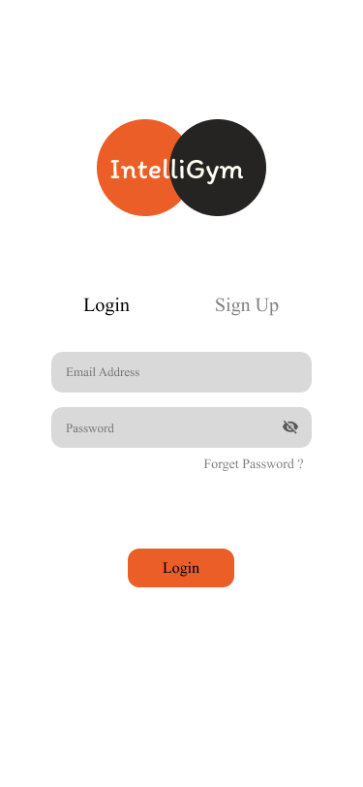

Figure 9 :Login Screen

### Sign Up Screen

**Overview:**

* **Functionality:** The Sign-Up screen serves as the entry point for new users to create accounts within the IntelliGym service. It collects essential information to establish their unique profiles and enable them to access the platform's features.
* **Key Elements:**
  + Username: Users choose a unique identifier that will represent them within the IntelliGym system.
  + Email Address: Users provide a valid email address that serves as a primary contact point for account-related communications and verification.
  + Password: Users create a secure password to protect their account and ensure authorized access.
  + Password Configuration: This field, while its exact purpose is unclear without further context, likely involves password strength checks or confirmation to promote robust security practices.
  + Create Account Button: Upon completion of the required fields, users initiate the account creation process by clicking this button.

**Summary:**

The Sign-Up screen plays a crucial role in user onboarding and account management within the IntelliGym service. Its intuitive design guides users through the account creation process, gathering necessary information to establish secure and personalized profiles, and ultimately enabling them to engage with the platform's features.

Figure 10: Sign Up Screen

### Forget Password Screen

**Overview:**

* **Functionality:** This screen enables users to securely reset their account password if they've forgotten it. It guides them through a simple process to regain access without requiring external assistance.
* **Key Elements:**
  + Clear Title: The screen prominently displays "Forgot Password" to immediately orient users and confirm its purpose.
  + Instructions: A concise message explains the steps involved, reassuring users and clarifying expectations.
  + Email Field: Users are prompted to enter the email address linked to their account, ensuring the reset link is sent to the correct recipient.
  + Send Link Button: This button initiates the password reset process. Upon clicking, the system generates and sends an email with a secure link to create a new password.
  + Success Message: A message like "Password reset email sent successfully" provides positive feedback and confirms completion of the initial step.
  + Back to Login Button: This option allows users to return to the login screen if they wish to try logging in again or have remembered their password.

**Summary:**

The Forgot Password screen serves as a vital security feature, empowering users to independently manage their account access. Its straightforward design and clear instructions facilitate a smooth password recovery experience.

Figure 11: Forgot Password Screen

### Dashboard screen

**Overview:**

* **Functionality:** The Dashboard screen serves as the central hub for users to access key information and features within the app. It provides a concise overview of essential elements and offers quick navigation to various functionalities, streamlining the user experience.
* **Key Elements:**

1. Header:

* Displays the app's logo and name prominently, reinforcing brand identity.
* Potentially includes a search bar or other global navigation elements

1. Dashboard Title:

* Clearly states the screen's purpose, enhancing clarity and focus.

1. Find a Nearby Gym:

* Prominent search feature specifically designed to locate gyms within the user's vicinity.
* Streamlines gym discovery and encourages user engagement.

1. Nearby Gyms:

* Displays a list of gyms in close proximity to the user's location.
* Includes essential details such as gym names, ratings, and distances

1. Popular Coaches:

* Highlights a selection of highly rated or sought-after fitness professionals.
* Fosters discovery and potential connections with reputable coaches

1. Navigation Menu:

* Provides access to other core app features, such as:
  + Profile
  + Workout plans
  + Tracking progress
  + Community features
  + Settings
* Enables seamless navigation and exploration of the app's offerings.

**Summary:**

The Dashboard screen acts as a comprehensive launchpad for users to engage with the app's core features. It prioritizes convenience and discovery, connecting users with nearby gyms, popular coaches, and essential functionalities. Its clear layout and intuitive navigation promote a user-friendly experience, encouraging exploration and engagement with the app's offerings.

Figure 12: dashboard Screen

### Gym Screen

**Overview:**

* **Functionality:** The Gym screen provides key information about a specific gym, including its name, contact details, rating, current status (open or closed), operating hours, and links to view posts and reviews.

It serves as a digital storefront for the gym, allowing users to quickly access essential information and potentially engage with the gym's social media presence.

* **Key Elements:**
  + Gym Name: Prominently displays the name of the gym, ".
  + Contact Information: Provides a direct way for users to contact the gym, likely through a phone number or email address.
  + Rating: Displays the gym's overall rating based on user reviews, giving potential visitors a glimpse into its reputation.
  + Status: Indicates whether the gym is currently open or closed, helping users plan their visits accordingly.
  + Operating Hours: Lists the gym's opening and closing times for each day of the week, ensuring users are aware of its availability.
  + Post Button: Offers a way to view posts made by the gym, potentially showcasing promotions, events, or general updates.
  + Reviews Button: Leads to a section where users can read reviews written by other customers, providing valuable insights into the gym's services and atmosphere.

**Summary:**

The Gym screen acts as a concise and informative hub for users to learn about a specific gym, its contact details, current status, operating hours, and online presence.

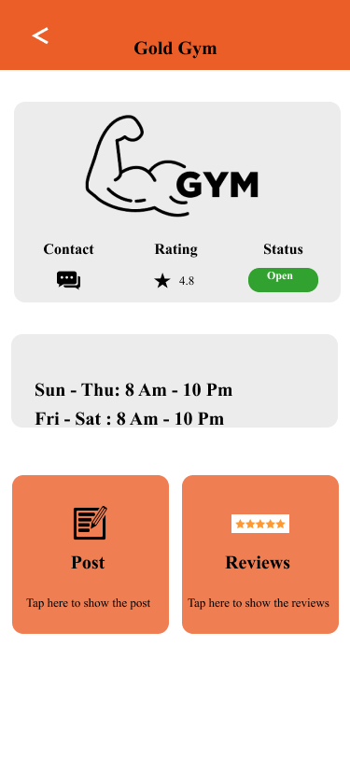

Figure 13: Gym Screen

### Coach Screen

**Overview:**

* **Functionality:** The Coach screen provides a centralized profile for a specific coach, enabling users to quickly access their essential information and connect with them.
* **Key Elements:**
  + Coach: Prominently displays the coach's name, establishing their identity as the focal point of the screen.
  + Email address: Offers a direct way to contact the coach for inquiries or consultations.
  + Rating: Showcases the coach's overall performance based on user feedback, providing a visual indicator of their quality and credibility.
  + Contact button: Facilitates direct communication with the coach, likely initiating an email or messaging option.
  + Availability: Clearly states the coach's working hours, helping users schedule interactions or appointments effectively.
  + Posts button: Potentially leads to a section where the coach shares insights, advice, or other relevant content.
  + Reviews button: Grants access to feedback from previous clients, enabling users to evaluate the coach's experience and effectiveness.

**Summary:**

The Coach screen serves as a comprehensive hub for engaging with a particular coach. It simplifies the process of connecting with them, assessing their expertise, and understanding their availability. It empowers users to make informed decisions about potential coaching engagements.

Figure 14: Coach Screen

### Profile screen

**Overview:**

* **Functionality:** The Profile screen serves as the central hub for users to view and manage their personal information and account-related settings within the app. It displays key details such as the user's name, email address, and account status, while also providing access to various management options.
* **Key Elements:**

1. Profile Header:

* Displays the user's full name prominently.
* Indicates the user's email address associated with their account.

1. Account Section:

* Payment: Likely directs users to manage payment methods for services or subscriptions within the app.
* Sessions History: Potentially allows users to review past activity or usage logs related to their account.
* App Settings: Redirects users to the dedicated app settings screen (previously explained).
* Edit Profile: Enables users to update their personal information or profile details.

1. General Section:

* Support: Provides options to contact customer support or access help resources.
* Terms of Services: Presents the legal terms and conditions governing the app's usage.
* Invite Friend: Facilitates sharing the app with others, potentially through referral links or social sharing options.
* Help: Offers access to in-app help guides or FAQs.

**Summary:**

The Profile screen offers a comprehensive overview of the user's account and acts as a gateway to various management features. It empowers users to personalize their experience, access support, review account history, and manage essential settings, all within a centralized location.

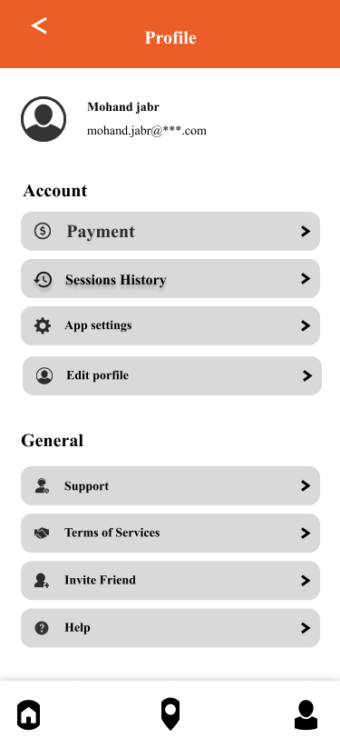

Figure 15: Profile screen

### App setting screen

**Overview:**

* **Functionality:** The App Settings screen provides a centralized location for users to customize various aspects of the app's behavior and tailor it to their preferences. It offers options to manage notifications, location services, visual appearance, security, and language.
* **Key Elements:**

1. Push Notifications:

* Toggle switch to enable or disable push notifications.
* When enabled, the app will send alerts and updates directly to the user's device.

1. Email Notifications:

* Toggle switch to enable or disable email notifications.
* When enabled, the app will send notifications via email.

1. Location Services:

* Toggle switch to enable or disable location tracking.
* When enabled, the app can access the user's location to provide location-based features, such as finding nearby gyms.

1. Switch to Dark Mode:

* Button to change the app's overall color scheme to a darker palette, often preferred for low-light environments or reduced eye strain.

1. Change Password:

* Option to update the password associated with the user's account.
* Enhances security by allowing users to regularly change their passwords.

1. Languages:

* Option to select the preferred language for the app's interface.
* Accommodates users with different language preferences.

1. Save Changes:

* Button to apply all the changes made within the settings screen.

**Summary:**

The App Settings screen empowers users to personalize their app experience, manage privacy settings, and enhance security by adjusting various preferences to match their individual needs and preferences.

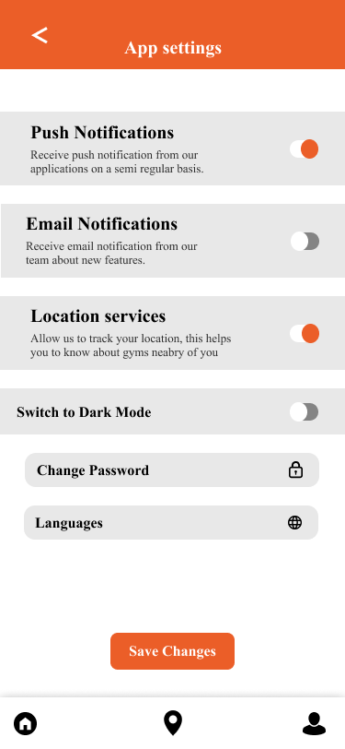

Figure 16: App setting screen

### Edit profile screen.

**Overview:**

* **Functionality:** The Edit Profile screen empowers users to update and manage their personal information and preferences within the app. It provides a user-friendly interface for making changes to various profile details, ensuring accuracy and personalization.
* **Key Elements:**

1. Edit Photo:

* Option to change the user's profile picture, which often serves as their visual representation within the app.
* Allows users to upload a new image or select one from their device's gallery.

1. Email Address:

* Displays the user's current email address associated with their account.
* May offer the ability to edit this field if the user needs to update their primary email address.

1. Your Name:

* Text field for entering or updating the user's full name, as it will be displayed throughout the app.

1. Your [Additional Information]:

* Section for providing or modifying other relevant details, such as:
  + Location
  + Bio or About Me section
  + Interests or preferences
  + Website link
  + Social media links
  + Contact information
* The specific fields available will vary depending on the app's purpose and features.

1. Save Changes:

* Button to apply all the changes made to the profile information.
* Triggers the app to update the user's profile with the new data.

**Summary:**

The Edit Profile screen promotes user control and personalization within the app. It enables users to maintain accurate and up-to-date information about themselves, fostering better connections and experiences within the app's community.

Figure 17: Edit profile screen

### Change Password Screen.

**Overview:**

* **Functionality:** The Change Password screen enables users to create a new password for their account while they are still logged in.

This allows them to proactively update their password for security reasons or if they suspect their current password has been compromised.

* **Key Elements:**
  + Current Password: Users must enter their current, active password to initiate the change process.
  + This verifies their identity and authorization to make changes to the account.
  + New Password: Users create and enter their desired new password in this field.
  + It's recommended to use a strong, unique password that combines upper and lowercase letters, numbers, and symbols.
  + Password Configuration: This section may contain guidelines or visual indicators to help users create a strong password.
  + It might display password strength meters or enforce specific complexity requirements.
  + Save & Submit: This button, when clicked, processes the new password information and updates the account's security settings.

**Summary:**

The Change Password screen is a crucial security feature that empowers users to take control of their account security.

Figure 18: Change Password Screen.

### Session history screen

**Overview:**

* **Functionality:** The Sessions History screen allows users to view a record of their past gym sessions. It displays key details about each session, including the gym location, date, time, duration, and cost. Users can view sessions for both the current week and the previous week.
* **Key Elements:**
  + Sessions History header: Clearly indicates the purpose of the screen.
  + Timeframe filter: Allows users to switch between viewing sessions for "This Week" or "Last Week."
  + Session list: Displays a list of past sessions, including:
  + Gym name: The name of the gym where the session took place.
  + Cost: The price of the session.
  + Duration: The length of the session, displayed in hours, minutes, and seconds.
  + Date: The day of the week when the session occurred.
  + Time: The time of day when the session began.
  + Location: The city where the gym is located.

**Summary:**

The Sessions History screen provides users with a convenient way to review their past gym activity.

Figure 19: Session History screen

### Payment screen

**Overview:**

* **Functionality:** The Payment screen enables users to securely enter their payment information to complete a transaction.

It facilitates the processing of payments for goods or services purchased within the application or website.

* **Key Elements:**

1. Payment Method:

* Clearly indicates the accepted payment method, in this case, credit card.

1. Credit Card Information:

* Your Name: Field for entering the cardholder's name as it appears on the credit card.
* Credit Card Number: Field for entering the full credit card number.
* Exp Date: Field for entering the credit card's expiration date.

1. Pay Now Button:

* Initiates the payment process upon submission of the entered information.

**Summary:**

The Payment screen serves as a crucial component of the checkout process.

It provides a clear and concise interface for users to input their payment details.

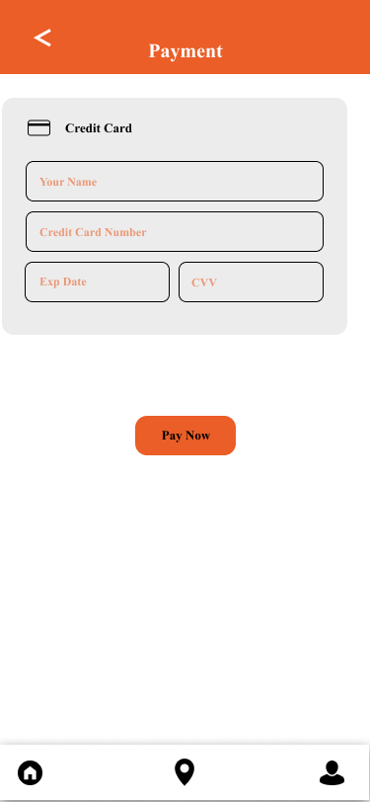

Figure 20: Payment screen

### QR Code screen

**Overview:**

* **Functionality:** The Scan QR Code screen serves as a secure and convenient method for users to connect to a service or device without manually entering login credentials.

It eliminates the need for manual typing, reducing errors and streamlining the authentication process.

* **Key Elements:**
  + QR Code: A visually distinctive square-shaped code displayed prominently on the screen, containing encoded information essential for establishing the connection.
  + Scan Button: A call-to-action button that initiates the scanning process, typically activated by a tap or a click.
  + Instruction Text: Clear and concise guidance directing the user to position their device's camera towards the QR code, ensuring accurate scanning.

**Summary:**

The Scan QR Code screen offers a user-friendly and efficient way to establish connections without the need for manual password entry.

Figure 21: QR code screen

### Timer screen

**Overview:**

* **Functionality:** The Timer screen provides a clear and focused interface for users to track and manage exercise time within the gym app. It displays the elapsed time prominently and offers essential controls for pausing, resuming, and ending workouts, ensuring efficient time management during exercise sessions.
* **Key Elements:**

1. Timer Display:

* Shows the current elapsed time in a bold and easily readable format.
* Indicates the duration of the ongoing exercise session.

1. GYM Banner:

* Prominently displays the word "GYM" to reinforce the context of the timer's usage.
* Visually connects the timer with the gym environment.

1. Gym:

* Potentially indicates the specific gym location where the user is exercising.
* May serve as a reminder of the user's chosen gym or provide context for data tracking.

1. Scan QR Code to End:

* Instructs users to scan a QR code to signal the completion of their workout.
* Implies an integrated system for tracking workout completion and potential check-out procedures.
* Promotes seamless interaction with gym equipment or facilities.

1. Tap to Scan:

* Interactive button that likely activates the device's camera for QR code scanning.
* Facilitates the completion process for users.

**Summary:**

The Timer screen simplifies time management and workout tracking within the gym app. Its clear display and straightforward controls empower users to effectively monitor their exercise sessions and seamlessly check out upon completion, enhancing the overall gym experience.

Figure 22: Timer screen

* 1. **Website Screen**

### Home Screen

**Overview:**

* File: Main.js.
* Functionality: provides the user an overall picture about our system and company.

**Implementation Details:**

The main screen page is a multi-component react file written in JavaScript language, which means that it has flexible parts.

The main screen uses ‘React Bootstrap’ components, such as navbar, buttons and Carousels, to achieve its functionality.

**Navigation Bar:**

The user needs to scan the QR code in order to continue. Point the camera at the code and press the "Scan" button to complete the task. Once scanned, the QR code will launch a page or app that is linked to it.

**Content:**

At the middle of the page, there is a multiple part of information split to:

1- Home: contains motivated sentence and 2 buttons (Join us, Learn more)

2- Service: shows the main idea of our products

3- Partners: shows our big partners like gyms, coaches, nutrition, or companies.

4- About: provides information about our system

5- Contact us

**Summary:**

The home page that appears when we enter our website before signing in or signing up includes a brief description of our website. It also features sections for our services, which provide a simple description of the services we offer. Another section is dedicated to our partners, including the companies or coaches who collaborate with us. Additionally, there is an "about" section that provides information about our system and company. Lastly, there is a "contact us" section that allows users to get in touch with us by providing their name, email, subject, and the message they wish to send.

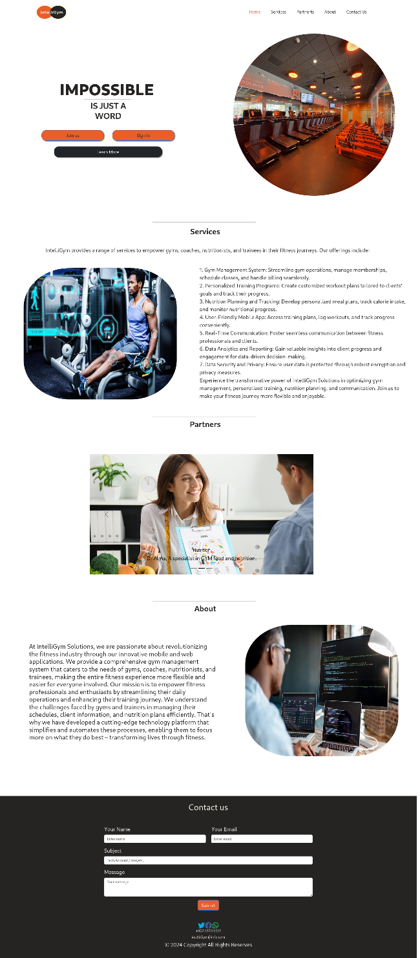

Figure 23:Home Screen

### Sign in & signup Screen.

**Overview:**

* File: `Joinus.js` and ‘Signin.js'
* Functionality: Provides an overview of the user's profile, posts, trainee statistics, and allows them to make posts and announcements, and displays user information, such as name and photo, and provides buttons for settings and sign out.

**Summary:**

Through our website, users have the option to sign in using an existing account or create a new account if they are using the web platform for the first time. When users click on the "Join Us" button, they are redirected to the Login or Register page. From there, they can enter their email and password to log in. Upon logging in, users will be directed to the User Overview Screen.

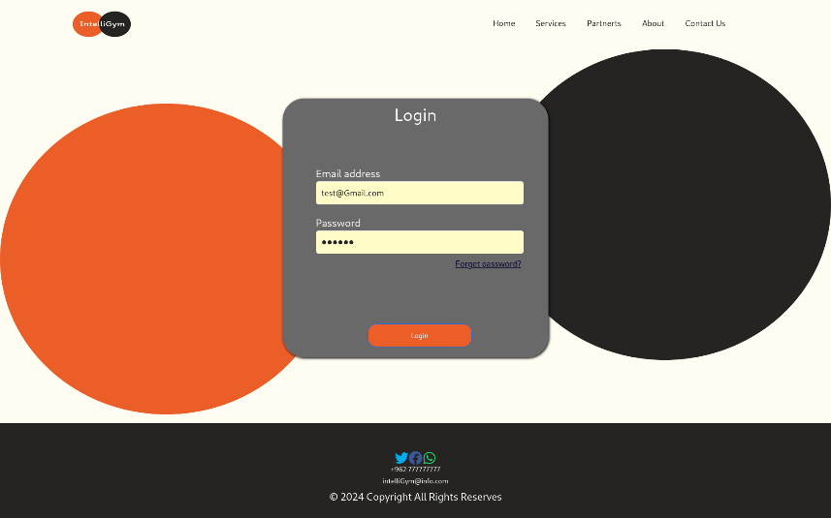

Figure 24:Sign in Screen

Figure 25: Join us screens

### Forgot Password Screen

**Overview**:

* File: ` ForgotPassword.js`
* Functionality The Forgot Password screen allows users to reset their account password if they have forgotten it. To do so, it prompts them to enter the email address associated with their account. The electronic service will then send an email containing a link to reset the password.
* **Key Elements:**
  + Email address: The user is prompted to enter the email address associated with their account.
  + Reset Password button: This button is used to send an email containing a link to reset the password.
  + Back to Login button: This button is used to return to the login screen.

**Summary:**

The Forgot Password screen is an important security feature that allows users to reset their account password if they have forgotten it. This provides users with a secure way to regain access to their accounts without having to contact customer support.

# 

Figure 26:Forgot Password Screen

### Main User Screen

**Overview:**

* File: `over.js` contains ‘sider.js’ and ‘footer.js'
* Functionality: Provides an overview of user profile, posts, and trainees' statistics, allows them to create, edit, and delete posts, view user information, and provides buttons for settings and logout.

**Implementation Details:**

The `over.js` file is a React component that utilizes various Ant Design components to create the desired functionality.

It uses state hooks such as `use State` and `use Effect` to manage the component's state and handle user interactions.

The component consists of two main sections: the post and announcement section and the trainee statistics section. In the post and announcement section, there is a text input area (`Text Area`) where the user can enter their post.

There are button, "Post" , which triggers the respective event handlers (`handle Post` ). These event handlers update the Fire store database using Firebase's `updateDoc` and `array Union` functions.

The component fetches data from Fire store using Firebase's `getDoc` function and updates the state variables accordingly.

The `use Effect` hook with an empty dependency array ensures that the data fetching and state updates occur only once during component initialization.

The `sider.js` file is a React component responsible for rendering a sidebar section of the user interface. It fetches user information from Fires tore using Firebase's `getDoc` function and sets the corresponding state variables.

The component uses Ant Design components, including `Avatar`, `Card`, and `Button`, to display the user's photo, name, and information. The user's information is fetched from Fire store and displayed in the card section. The buttons for settings and sign out are implemented as links (`<a>` tags) that navigate to the specified routes.

The `footer.js` file is a React component that renders a footer section at the bottom of the page. It uses the `Facebook’, ‘Twitter`, and `WhatsApp` icons from the `react-icons/fa` library to display social media icons.

**Summary:**

Once users access the User Overview Screen, they will find options to create posts (which are saved on the same page) or view announcements, which are notifications received within our application. The screen also displays the status of active trainees and the number of posts. Additionally, users can navigate to the Settings page or sign out from this screen.

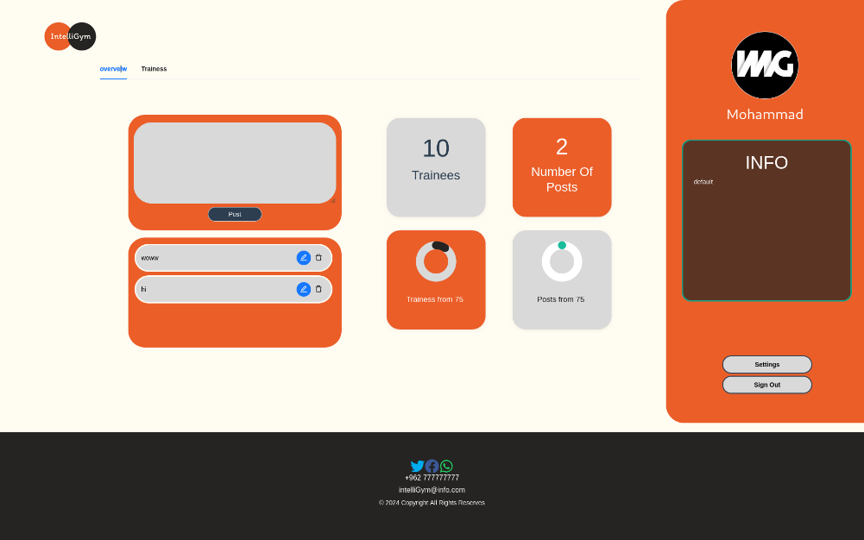

Figure 27: Main User Screen

### Trainees Screen

* File: ` trainees.js`
* Functionality: This page allows the trainer to view a list of their subscribers. The list includes the subscriber's name. The trainer can also send notifications to all subscribers or to a specific subscriber.
* **Key Elements:**
  + Subscriber list: This list displays the names.
  + Send notification: This button allows the trainer to send a notification to all subscribers.
  + Send notification to: This button allows the trainer to send a notification to a specific subscriber.

**Summary:**

This page provides the trainer with a convenient way to view their subscribers and send notifications to them.

Figure 31:Trainees Screen

### Setting Screen

**Overview**:

* File: `Setting.js` contains ‘siderr.js’,‘footer.js and ‘personal.js’'
* Functionality: Provides an ability for editing user's profile information like; name, photo, phone, location, costs, available time, and info (about yourself).

**Implementation Details:**

The `Setting.js` file is a React component that utilizes various Ant Design components to create the desired functionality.

’personal.js’ component imports dependencies from the Ant Design library, as well as other modules such as Firebase and Fire store. It declares several state variables using the ‘use State’ hook, including form, pic, ‘edit Mode’, info, and button. The ‘use Effect’ hook is used to fetch the user's data from Firebase when the component mounts. It sets the info state variable with the retrieved data and also sets the corresponding form field values.

The ‘handle Change’ function is responsible for updating the info state object when the input values change. The ‘on Finish’ function is a placeholder for handling the form submission. The ‘handle Edit’ function sets the edit Mode state variable to true, enabling the editing of the form. The handle Cancel function sets the edit Mode state variable to false, canceling the editing process.

The ‘change Photo’ function is called when the user selects a profile picture. It updates the pic state variable with the selected image URL and sets the form field value accordingly. The ‘handle Save’ function is responsible for validating and saving the form data to Firebase. It disables the edit mode, updates the pic state variable in the form data, and triggers a reload of the page.

The component renders a form using the Form component from Ant Design. The ‘form’ consists of several ‘Form. Item’ components representing different fields such as name, location, phone, email, cost, open Default, open Friday, and info. Each ‘Form. Item’ contains an ‘Input’ component for user input.

The profile picture is displayed using an’ Avatar’ component, and the user can upload a new photo by clicking on the "Upload Photo" button. The selected photo is displayed using the profile Pic element and the pic state variable. When in edit mode, the user can click on the "Save" button to trigger the ‘handle Save’ function and save the form data. When not in edit mode, the user can click on the "Edit" button to enable editing. The component is exported as Personal.

The `sider.js` file is a React component responsible for rendering a sidebar section of the user interface. It fetches user information from Fire store using Firebase's `getDoc` function and sets the corresponding state variables.

The component uses Ant Design components, including `Avatar`, `Card`, and `Button`, to display the user's photo, name, and information. The user's information is fetched from Fire store and displayed in the card section. The buttons for settings and sign out are implemented as links (`<a>` tags) that navigate to the specified routes.

The `footer.js` file is a React component that renders a footer section at the bottom of the page. uses the `Facebook’, ‘Twitter`, and `WhatsApp` icons from the `react-icons/fa` library to display social media icons.

**Summary:**

Personal Info Setting page. Here, users can upload a profile picture and provide their username, country, mobile phone number, email, subscription pricing (for gym, coach, or nutrition services), rand additional information about themselves.

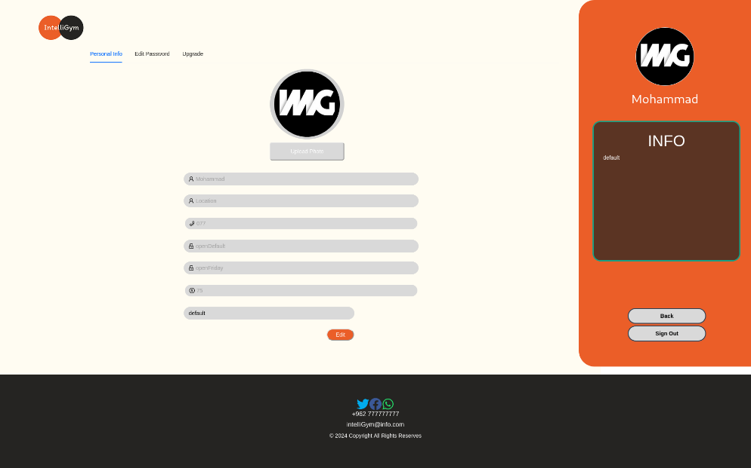

Figure 28:Setting Screen

### Change Password Screen

**Overview:**

* File: `EditPassword.js`
* Functionality: Enables users to securely update their account password.
* Key elements:
  + Input fields for new password, and new password confirmation
  + "Change Password" button to initiate password modification.

**Summary:**

The Change Password Screen empowers users to maintain the security of their accounts by facilitating password updates in a straightforward and user-friendly manner.

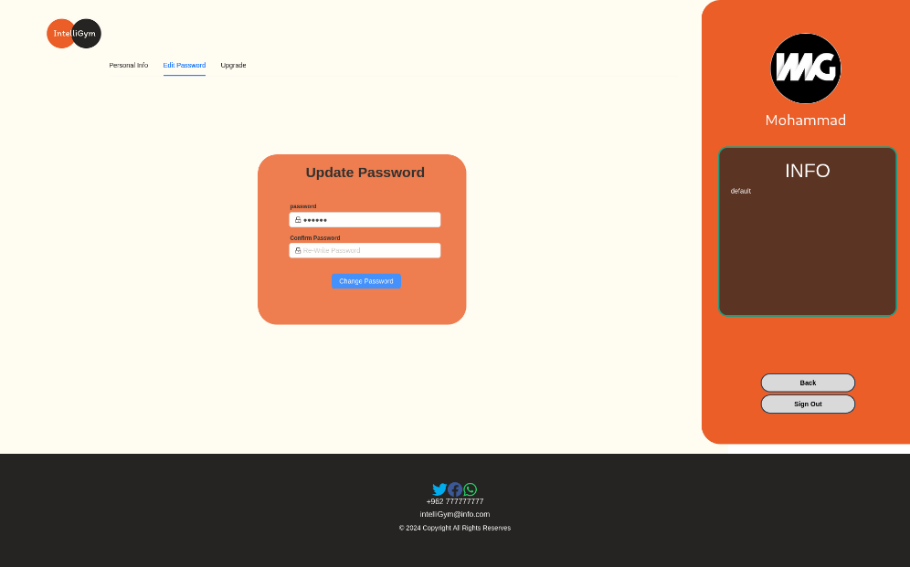

Figure 30:Change Password Screen

### Upgrade Plan Screen

**Overview:**

* File: `upgrade.js`
* Functionality: Display current plan and expiration date, allow users to choose or modify plans, and update their subscription accordingly. Accessible through settings for easy management.

**Summary**:

This page displays the current plan for the user and the expiration date. There are three types of registration plans, and the user can choose the appropriate plan or make modifications to it. By simply clicking on "Subscribe," the plan will be changed accordingly. The user can access this page through the settings.

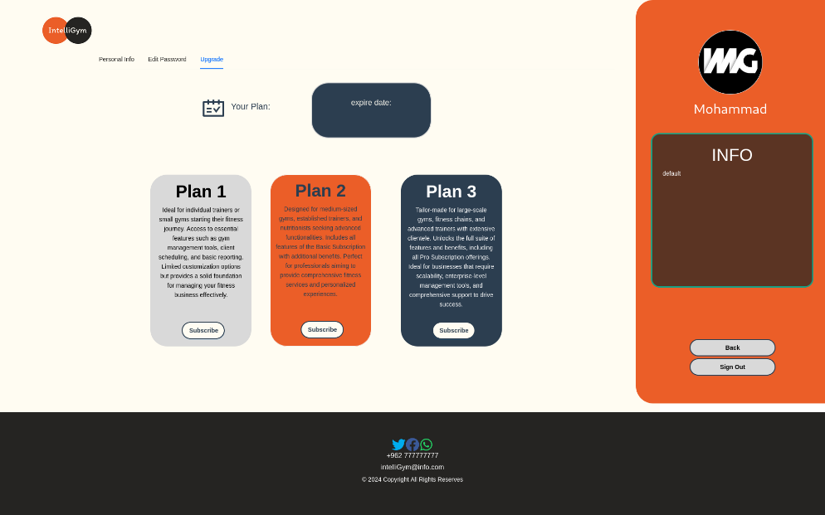

Figure 29:Upgrade Screen

# CONCLUSION

In conclusion, by offering a thorough and practical platform for users to track their progress, the IntelliGym mobile application seeks to transform the fitness sector, connect with top coaches and nutritionists, and stay on top of their fitness goals. With its innovative features such as QR code scanning, real-time session tracking, and a directory of nearby gyms, the IntelliGym app provides users with everything they need to achieve their fitness goals in one centralized place. Additionally, with its focus on security and ease of use, IntelliGym sets itself apart from its competitors and provides a unique and valuable solution for the modern fitness enthusiast. Overall, the IntelliGym project represents a major step forward in the world of mobile fitness and is poised to make a significant impact on the industry.

# REFERENCES

|  |  |
| --- | --- |
| [1] | classpass, [Online]. Available: https://classpass.com/. [Accessed 10 September 2023]. |
| [2] | Yoma, [Online]. Available: https://www.yomapp.com/. [Accessed 10 September 2023]. |
| [3] | "GetMuv," 1Pass, [Online]. Available: https://www.1pass.app/en. [Accessed 10 September 2023]. |
| [4] | A. Banks and E. Porcello, Learning React: Functional Web Development with React, New York: O’Reilly Media, 2018. |
| [5] | M. Thomas, React in Action, Greenwich: Manning Publications, 2018. |
| [6] | S. Stefanov, React: Up & Running: Building Web Applications, Bern, Switzerland: O'Reilly Media, 2021. |
| [7] | google, "Flutter: Build beautiful, natively compiled, multi-platform applications from a single codebase," [Online]. Available: https://flutter.dev/. [Accessed 31 August 2023]. |
| [8] | M. Pilgrim, Dart: Up and Running, O'Reilly Media, 2013. |
| [9] | Google, "Firebase | Google's Mobile and Web App Development platform," 2023. [Online]. Available: https://firebase.google.com/. [Accessed 31 August 2023]. |
| [10] | M. Biehl, RESTful API Design (API-University Series), CreateSpace Independent Publishing Platform, 2016. |
| [11] | Flutter, "FAQ," Flutter, [Online]. Available: https://docs.flutter.dev/resources/faq. [Accessed 3 January 2024]. |
| [12] | Firebase, "Firebase Authentication," Google, [Online]. Available: https://firebase.google.com/docs/auth. [Accessed 3 January 2024]. |
| [13] | Github, "Github docs," 2023. [Online]. Available: https://docs.github.com/en. [Accessed 15 December 2023]. |
| [14] | medium, "React Bootstrap: Building Beautiful and Responsive Web Applications," 2024. [Online]. Available: https://medium.com/@livajorge7/react-bootstrap-building-beautiful-and-responsive-web-applications-2dbd35e4ffb2. [Accessed 3 january 2024]. |